SAP Design for DMS Solution

SAP TEAM – SAP B1 INSTALLATION GUIDE – 3/27/2017

Customer logo

*Prepared by*

**DMSpro**

*Contribute by*

**DMSpro**

**SAP B1 Installation Guide**

Table of Contents

Table of Contents 2

1. Revision and Signoff 6

1.1. Change Record 6

1.2. Reviewers 6

2. Setup IIS 7

3. Setup SQL Server 7

4. Setup SAP B1 Server 7

4.1.1. Step 1: Run Setup Package 7

4.1.2. Step 2: Select Perform Setup 8

4.1.3. Step 3: Select New Configuration 9

4.1.4. Step 4: Select Install Local System Landscape Directory 10

4.1.5. Step 5: Config SLD 11

4.1.6. Step 6: Config [B1SiteUser] Password 12

4.1.7. Step 7: Register Database 13

4.1.8. Step 8: Config Database Information 14

4.1.9. Step 13: Choose Options 15

4.1.10. Step 14: Choose Options (Next) 16

4.1.11. Step 15: System SLD Preferences 17

4.1.12. Step 16: Browser Access Service 18

4.1.13. Step 17: Select [Use Self-Signed Certificate] 19

4.1.14. Step 18: Select Client Version (x86 or x64) 20

4.1.15. Step 19: Review Settings 21

4.1.16. Step 20: Review Settings (Next 1) 22

4.1.17. Step 21: Review Settings (Next 2) 23

4.1.18. Step 22: Review Settings (Next 3) 24

4.1.19. Step 23: Review Settings (Next 4) 25

4.1.20. Step 24: Review Settings (Next 5) 26

4.1.21. Step 25: Review Settings (Next 6) 27

4.1.22. Step 26: Review Settings (Next 7) 28

4.1.23. Step 27: Confirm for Next Step 29

4.1.24. Step 28: Setup Summary 30

4.1.25. Step 29: Setup Summary (Next) 31

4.1.26. Step 30: Processing… (SLD, License Manager,…) 32

4.1.27. Step 32: Processing… (Repository: SBO-Common Database) 33

4.1.28. Step 33: Processing… 34

4.1.29. Step 34: Processing… (Help) 35

4.1.30. Step 35: Processing… (RSP) 36

4.1.31. Step 36: Setup Support Platform 37

4.1.32. Step 37: Click Next to Continue 37

4.1.33. Step 38: Setup Type 38

4.1.34. Step 39: Config RSP 38

4.1.35. Step 40: Config RSP 39

4.1.36. Step 41: Config RSP 39

4.1.37. Step 42: Config RSP 40

4.1.38. Step 46: Destination Folder 40

4.1.39. Step 47: Confirm Create Destination Folder 41

4.1.40. Step 49: Select Defaults 41

4.1.41. Step 50: Review Settings 42

4.1.42. Step 51: Review Settings (Next 1) 42

4.1.43. Step 52: Review Settings (Next 2) 43

4.1.44. Step 53: Processing… 43

4.1.45. Step 54: Processing… 44

4.1.46. Step 55: Finish Setup RSP 44

4.1.47. Step 56: Processing.. (DI API: x86) 45

4.1.48. Step 57: Processing… 46

4.1.49. Step 58: Processing… (DI API: x64) 47

4.1.50. Step 59: Processing… (SAP B1 Client) 48

4.1.51. Step 60: Processing (Browser Access) 49

4.1.52. Step 61: Processing… 50

4.1.53. Step 62: Processing… (Data Transfer Workbench) 50

4.1.54. Step 63: Processing… (DTW: Welcome) 51

4.1.55. Step 64: Processing… (DTW: Destination Folder) 51

4.1.56. Step 65: Processing… (DTW: Program Folder) 52

4.1.57. Step 66: Processing… (DTW: Review Settings) 52

4.1.58. Step 67: Processing… 53

4.1.59. Step 68: Processing… (DTW: Finish) 53

4.1.60. Step 69: Processing… (DTW: x64) 54

4.1.61. Step 70: Setup Success 55

4.1.62. Step 71: Setup Success (Next) 56

4.1.63. - Finish - 56

5. Maintainance B1 System 56

5.1. Register New Repository 57

5.1.1. Step 1: Setup Welcome 57

5.1.2. Step 2: Setup Type 58

5.1.3. Step 3: Select New Configuration 59

5.1.4. Step 4: Config SLD 60

5.1.5. Step 5: Config [B1SiteUser] Password 61

5.1.6. Step 6: Config Database Connection 62

5.1.7. Step 8: Input Database Information 63

5.1.8. Step 9: Finish Config Database 64

5.1.9. Step 10: Select [Repository] Only 65

5.1.10. Step 11: Review Settings 66

5.1.11. Step 12: Begin Setup 67

5.1.12. Step 13: Processing… (Repository) 68

5.1.13. Step 14: Processing… 69

5.1.14. Step 15: Processing… 70

5.1.15. Step 16: Processing… 71

5.1.16. Step 17: Processing… 72

5.1.17. Step 18: Processing… 73

5.1.18. Step 19: Processing… (Help) 74

5.1.19. Step 20: Setup Success 75

5.1.20. Step 21: Sutup Success (Next) 76

5.1.21. - Finish - 76

5.2. Setup SAP Server Tools 76

5.2.1. Step 1 76

5.2.2. Step 2 77

5.2.3. Step 3 77

5.2.4. Step 4 78

5.2.5. Step 5 78

5.2.6. Step 6 79

5.2.7. Step 7 79

5.2.8. Step 8 80

5.2.9. Step 9 80

5.2.10. Step 10 81

5.2.11. Step 11 81

5.2.12. Step 12 82

5.2.13. Step 13 82

5.2.14. - Finish - 82

6. Setup S.Service 82

6.1. Setup Website 83

6.1.1. Step 1: Open IIS Management 83

6.1.2. Step 2: Create Application Pool 83

6.1.3. Step 3: Set AppPool Name 84

6.1.4. Step 4: Config AppPool 84

6.1.5. Step 5: Open Advanced Settings 85

6.1.6. Step 6: Select Identity 86

6.1.7. Step 7: Change Identity 86

6.1.8. Step 8: LocalSystem Identity 87

6.1.9. Step 9: Finish Change Identity 87

6.1.10. Step 10: Create new Website 88

6.1.11. Step 11: Config Information 89

6.1.12. Step 12: Uncheck [Start Website immediately] 90

6.1.13. - Press OK to Finish - 90

6.2. Setup Window Service 90

7. Appendix A 90

7.1. Glossary of Terms 90

# Revision and Signoff

## Change Record

Table 1: Change Record

|  |  |  |  |
| --- | --- | --- | --- |
| Date | Author | Version | Change reference |
| 03/27/2017 | SAP Team | 1.0 | Initialize Document |
|  |  |  |  |

## Reviewers

Table 2: Reviewers

|  |  |  |  |
| --- | --- | --- | --- |
| Name | Version approved | Position | Date |
|  |  |  |  |
|  |  |  |  |
|  |  |  |  |

# Setup IIS

# Setup SQL Server

# Setup SAP B1 Server

### Step 1: Run Setup Package

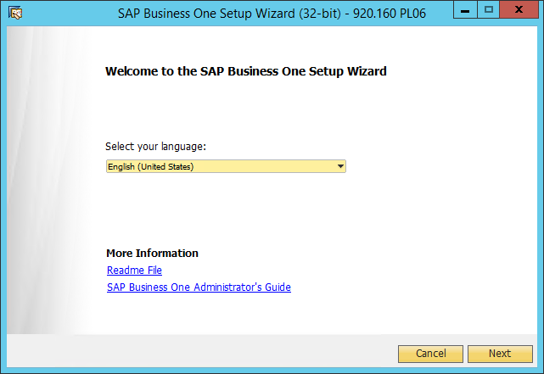

### Step 2: Select Perform Setup

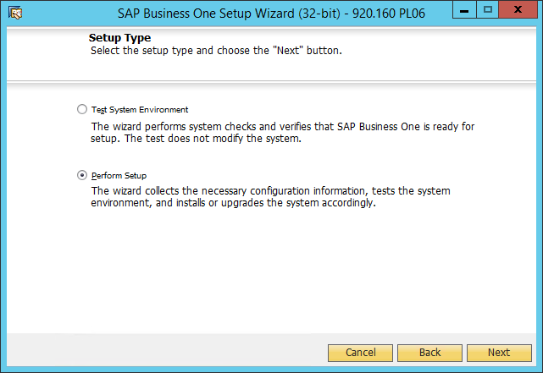

### Step 3: Select New Configuration

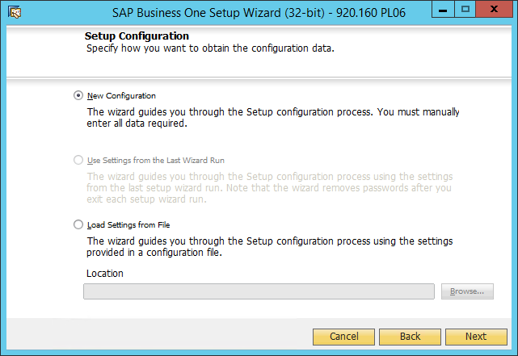

### Step 4: Select Install Local System Landscape Directory

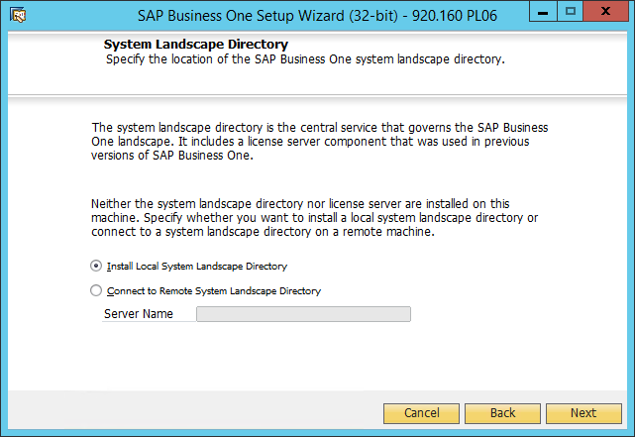

### Step 5: Config SLD

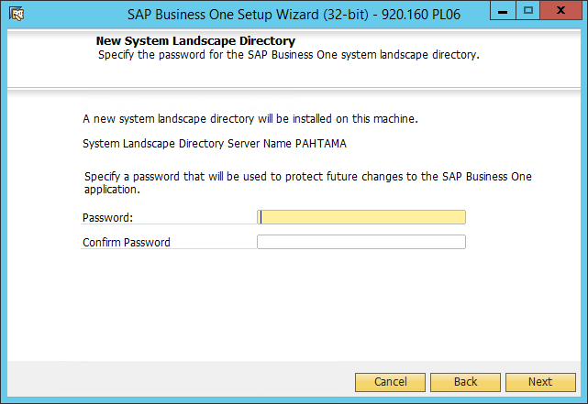

### Step 6: Config [B1SiteUser] Password

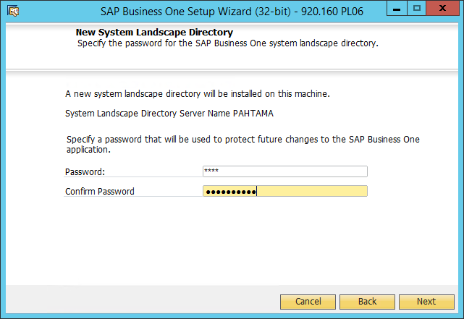

### Step 7: Register Database

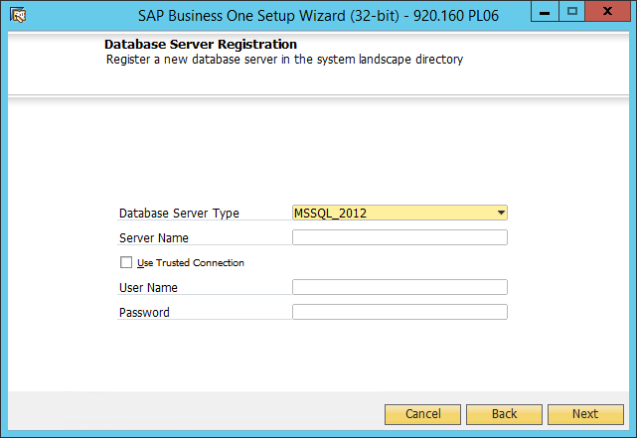

### Step 8: Config Database Information

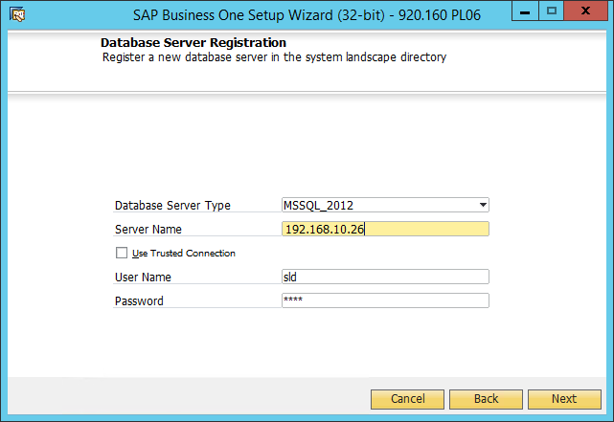

### Step 13: Choose Options

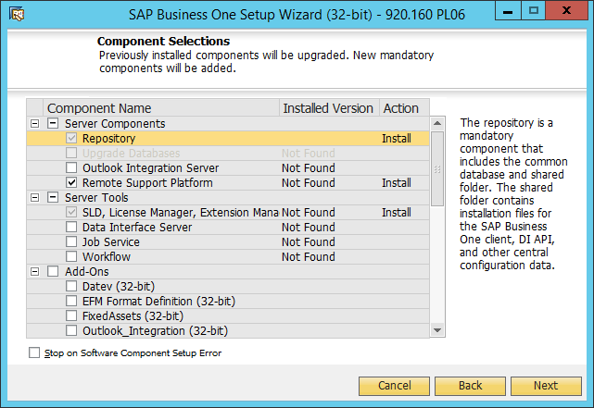

### Step 14: Choose Options (Next)

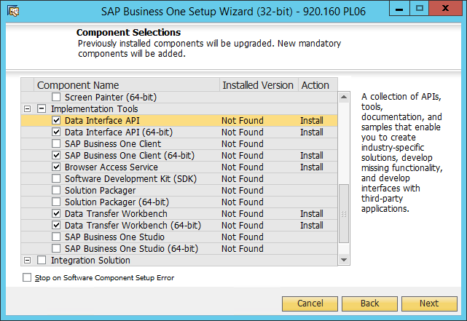

### Step 15: System SLD Preferences

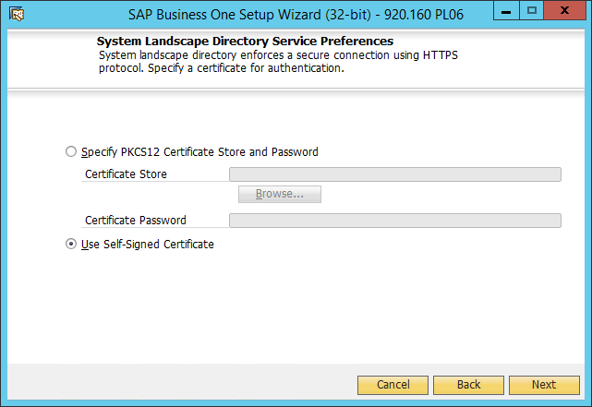

### Step 16: Browser Access Service

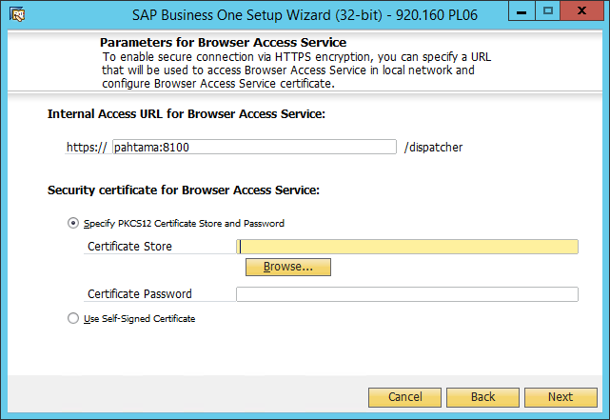

### Step 17: Select [Use Self-Signed Certificate]

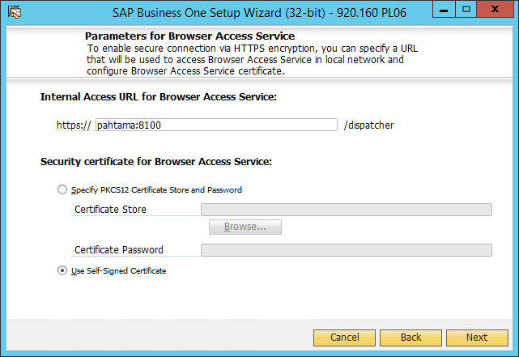

### Step 18: Select Client Version (x86 or x64)

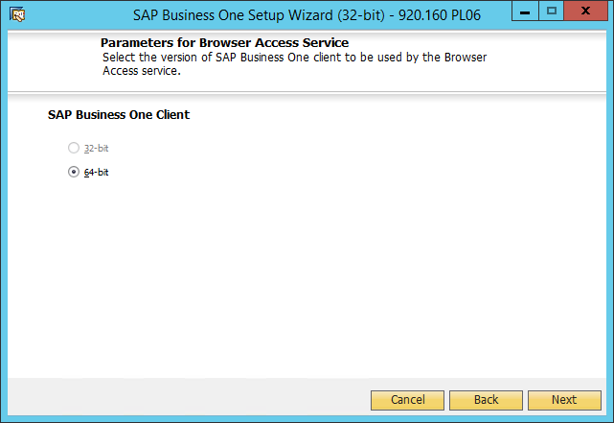

### Step 19: Review Settings

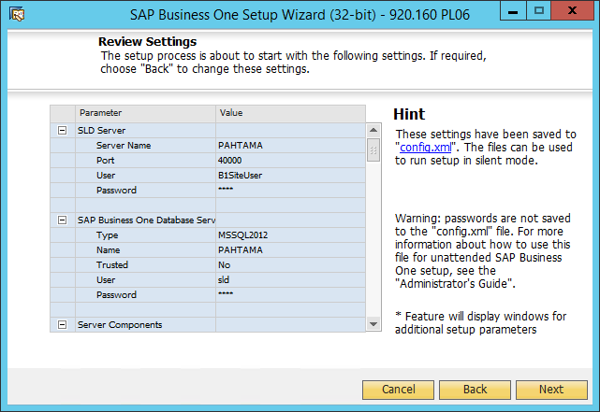

### Step 20: Review Settings (Next 1)

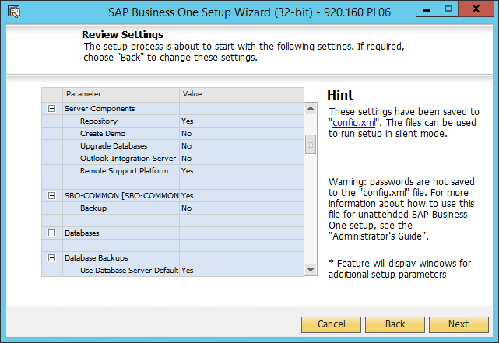

### Step 21: Review Settings (Next 2)

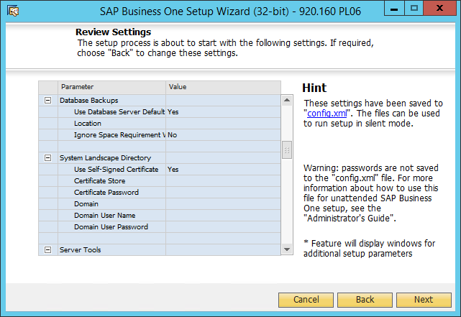

### Step 22: Review Settings (Next 3)

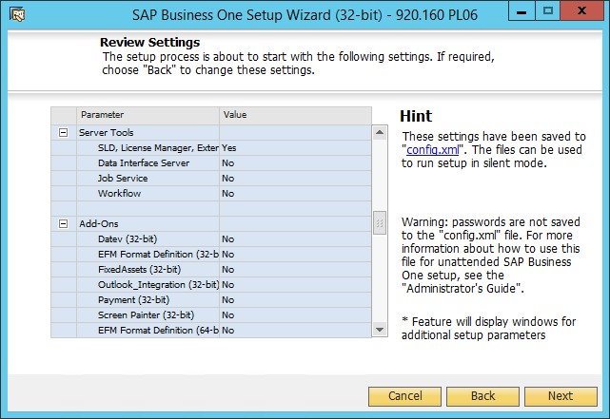

### Step 23: Review Settings (Next 4)

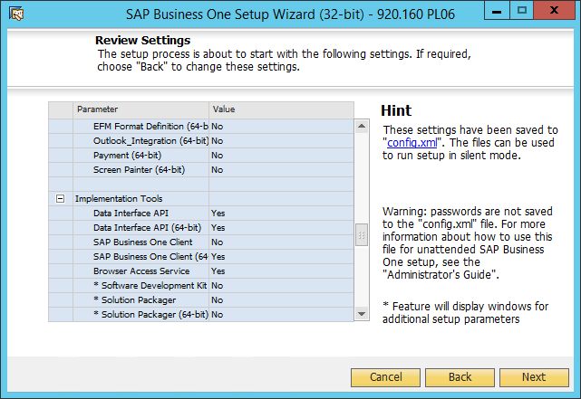

### Step 24: Review Settings (Next 5)

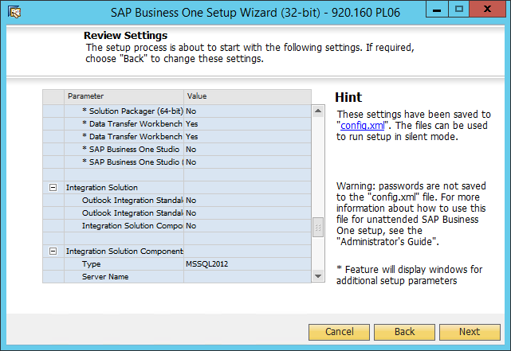

### Step 25: Review Settings (Next 6)

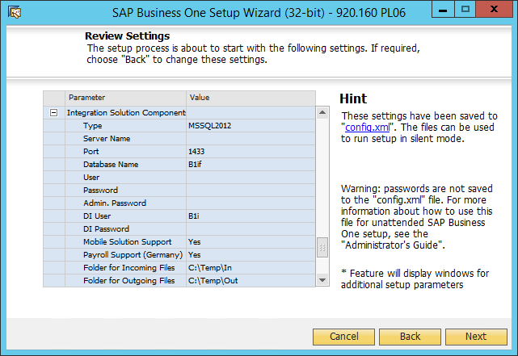

### Step 26: Review Settings (Next 7)

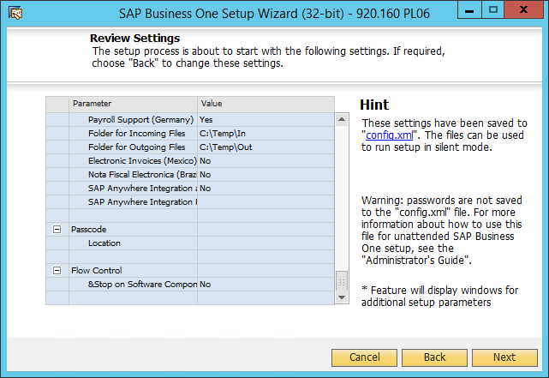

### Step 27: Confirm for Next Step

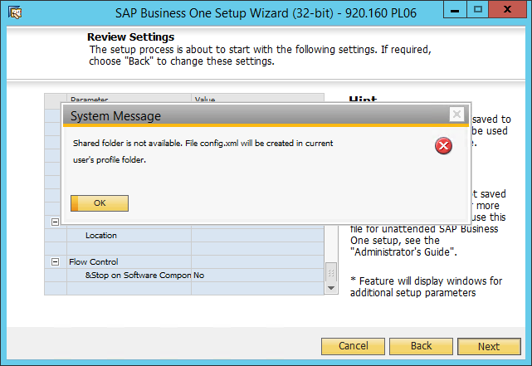

### Step 28: Setup Summary

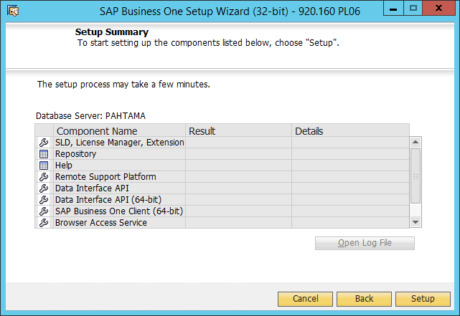

### Step 29: Setup Summary (Next)

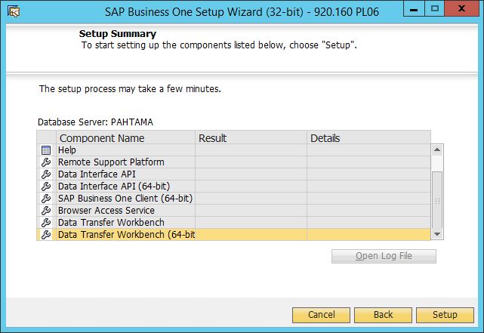

### Step 30: Processing… (SLD, License Manager,…)

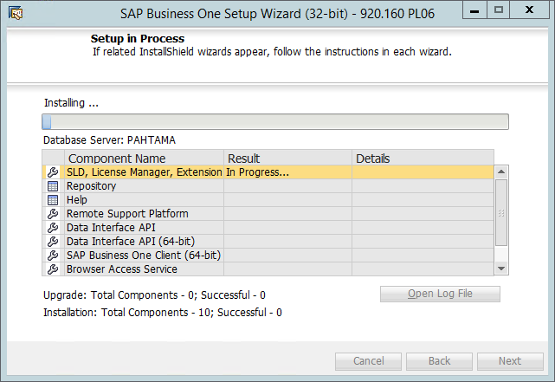

### Step 32: Processing… (Repository: SBO-Common Database)

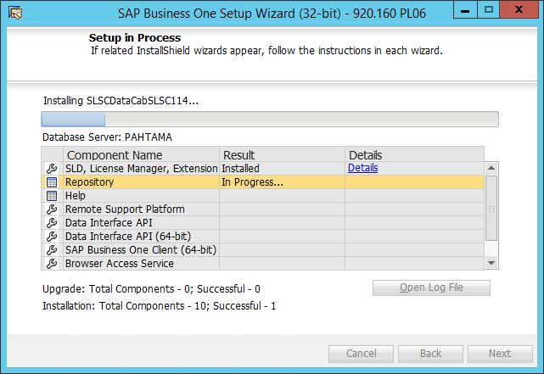

### Step 33: Processing…

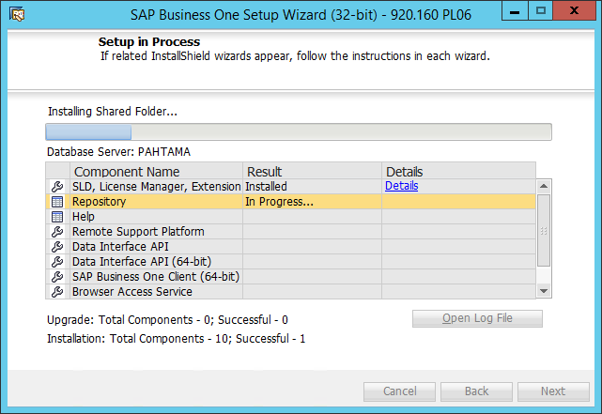

### Step 34: Processing… (Help)

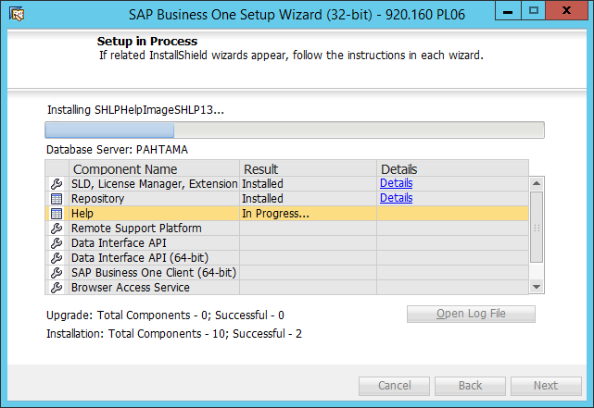

### Step 35: Processing… (RSP)

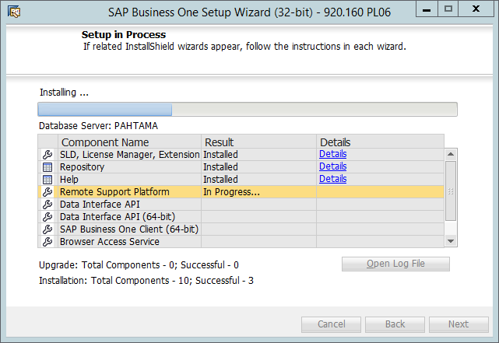

### Step 36: Setup Support Platform

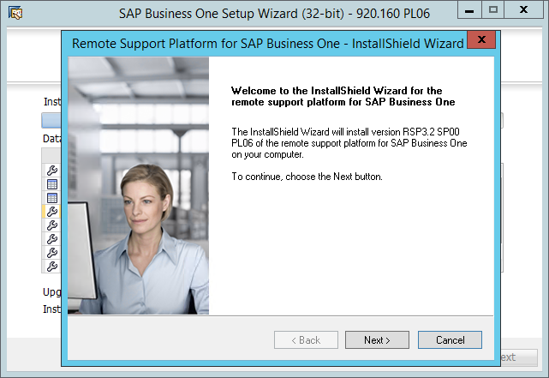

### Step 37: Click Next to Continue

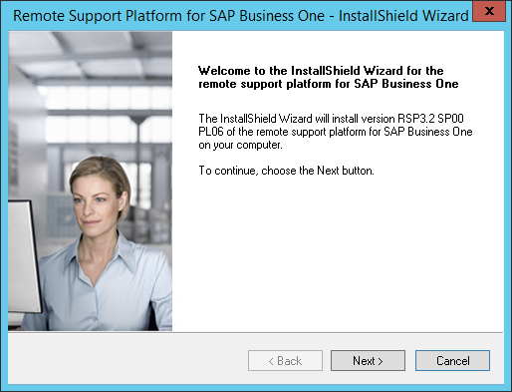

### Step 38: Setup Type

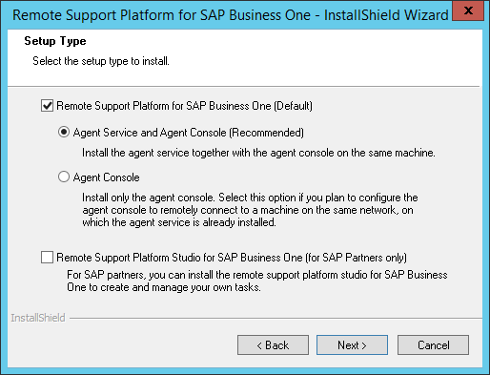

### Step 39: Config RSP

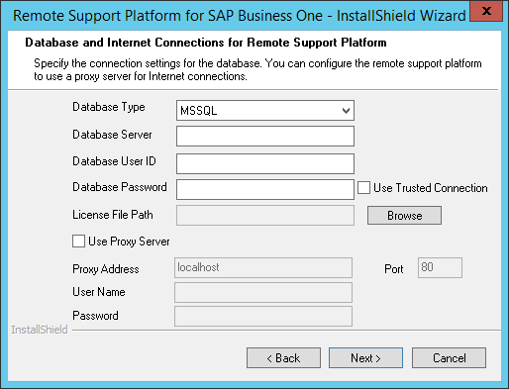

### Step 40: Config RSP

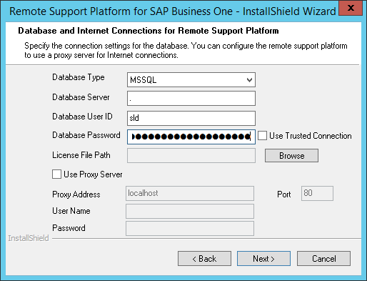

### Step 41: Config RSP

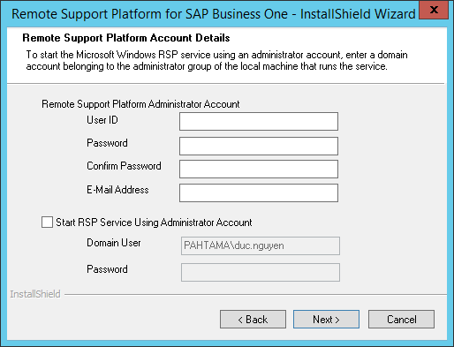

### Step 42: Config RSP

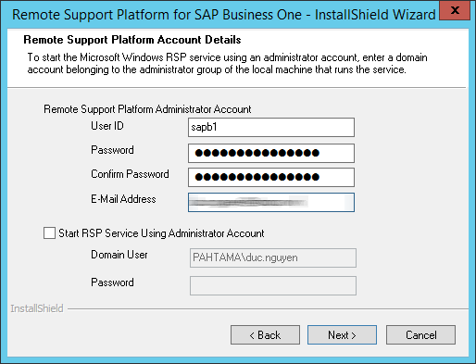

### Step 46: Destination Folder

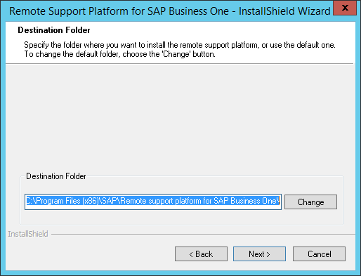

### Step 47: Confirm Create Destination Folder

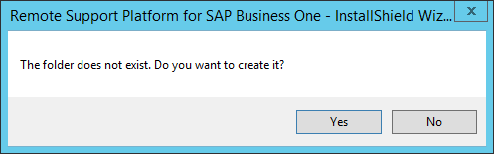

### Step 49: Select Defaults

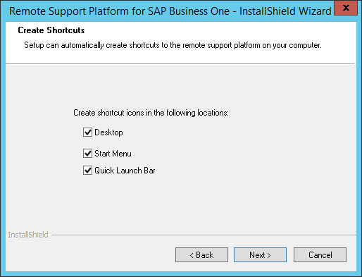

### Step 50: Review Settings

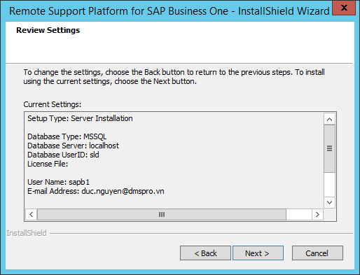

### Step 51: Review Settings (Next 1)

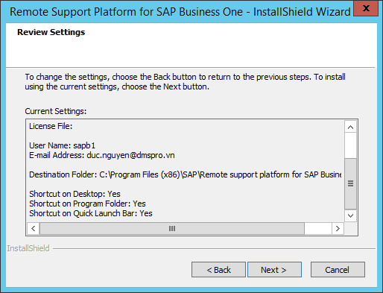

### Step 52: Review Settings (Next 2)

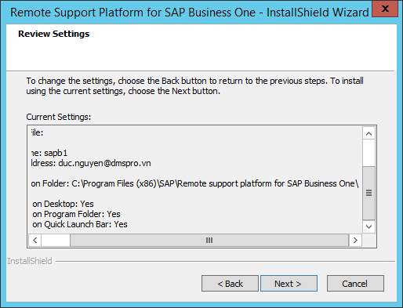

### Step 53: Processing…

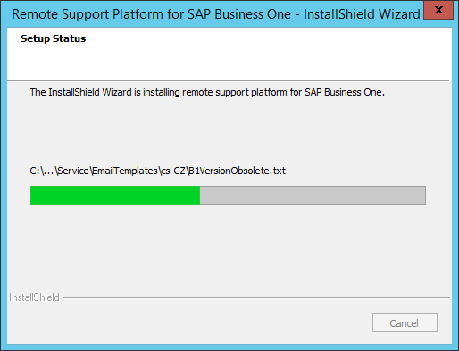

### Step 54: Processing…

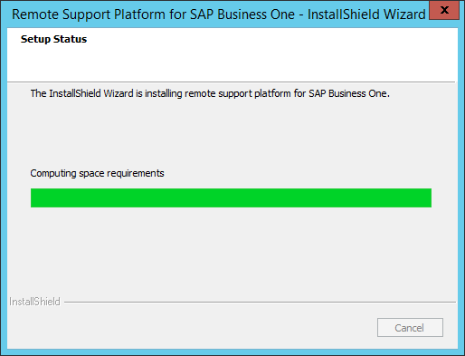

### Step 55: Finish Setup RSP

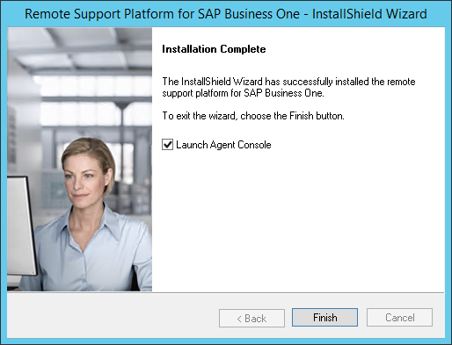

### Step 56: Processing.. (DI API: x86)

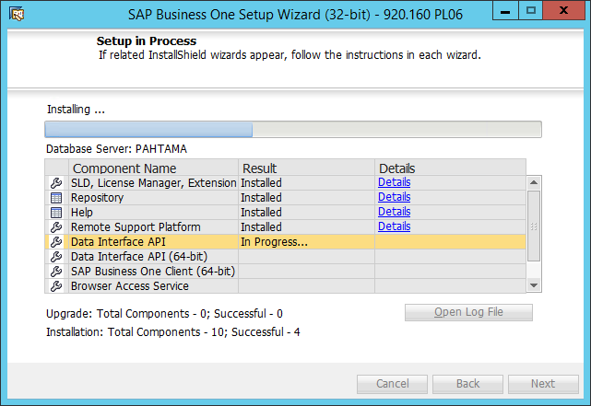

### Step 57: Processing…

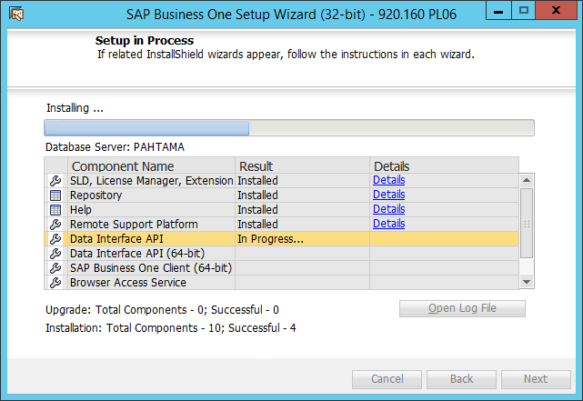

### Step 58: Processing… (DI API: x64)

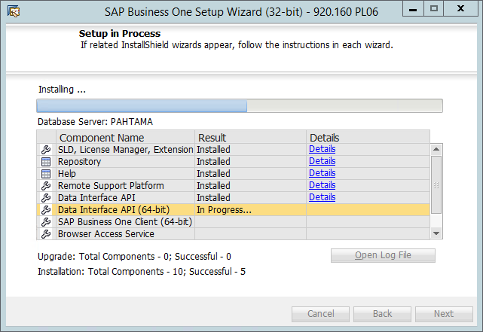

### Step 59: Processing… (SAP B1 Client)

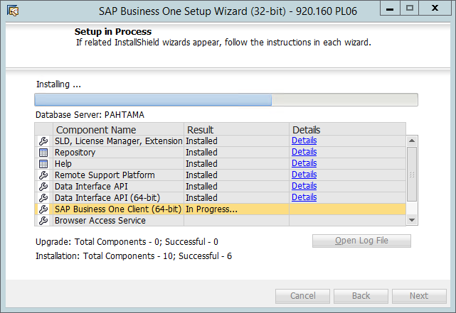

### Step 60: Processing (Browser Access)

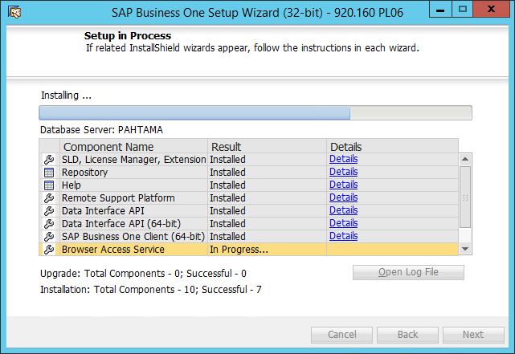

### Step 61: Processing…

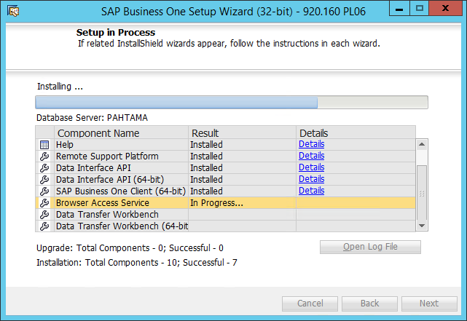

### Step 62: Processing… (Data Transfer Workbench)

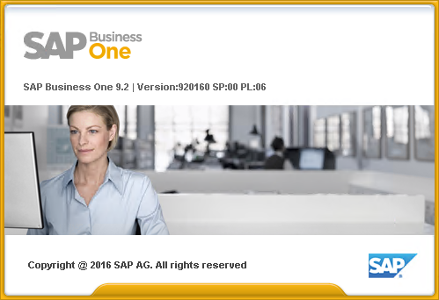

### Step 63: Processing… (DTW: Welcome)

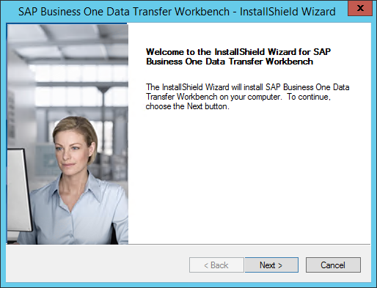

### Step 64: Processing… (DTW: Destination Folder)

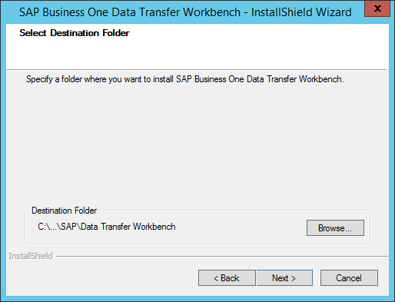

### Step 65: Processing… (DTW: Program Folder)

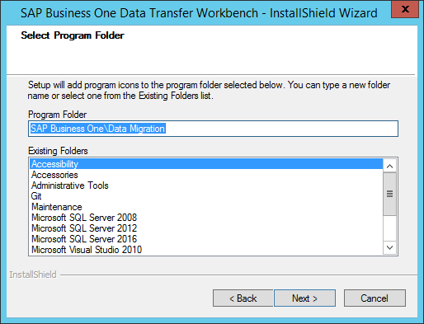

### Step 66: Processing… (DTW: Review Settings)

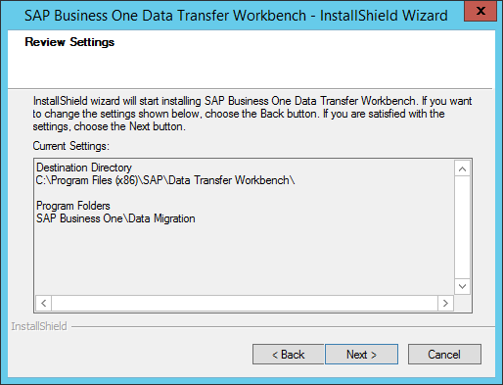

### Step 67: Processing…

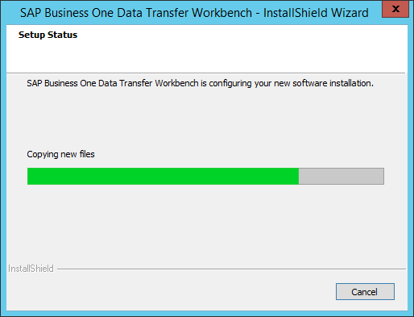

### Step 68: Processing… (DTW: Finish)

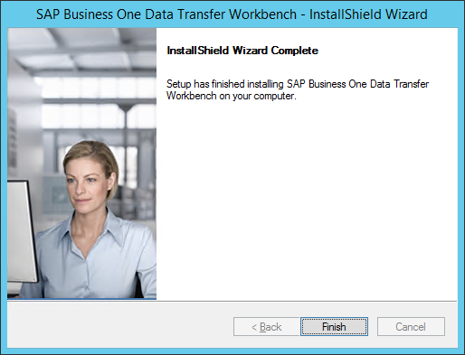

### Step 69: Processing… (DTW: x64)

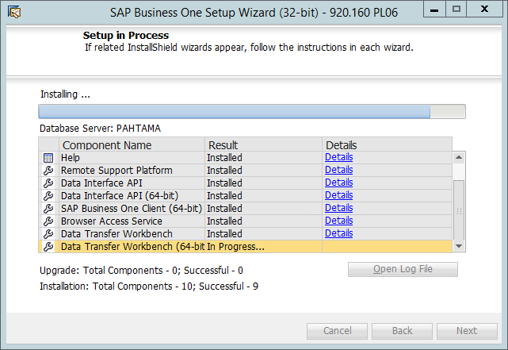

### Step 70: Setup Success

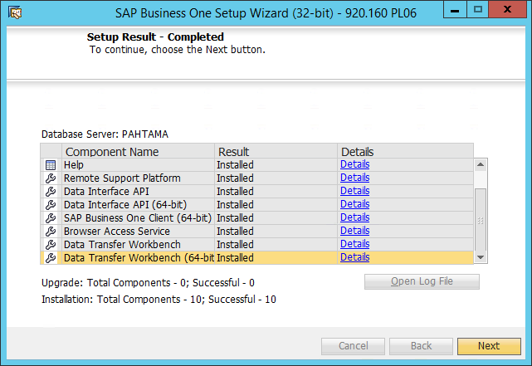

### Step 71: Setup Success (Next)

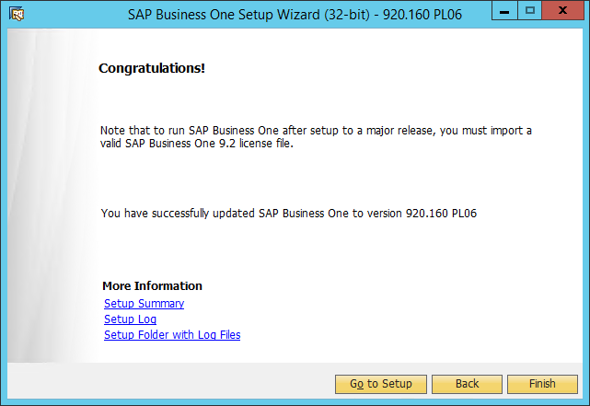

### - Finish -

# Maintainance B1 System

## Register New Repository

### Step 1: Setup Welcome

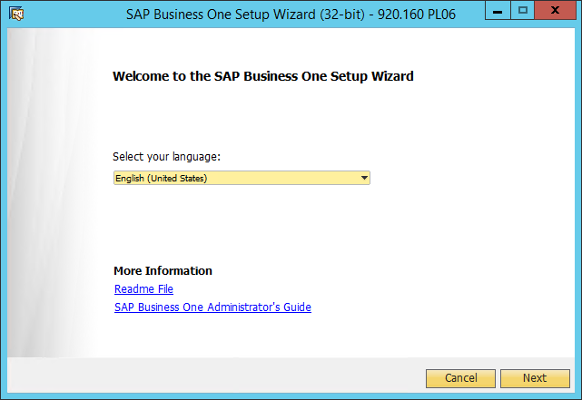

### Step 2: Setup Type

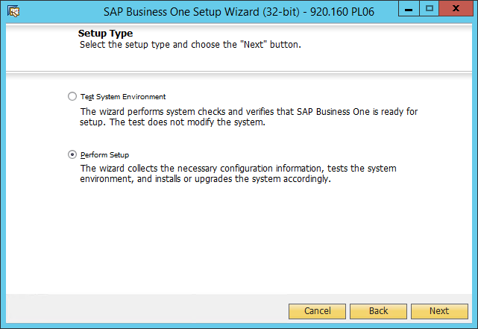

### Step 3: Select New Configuration

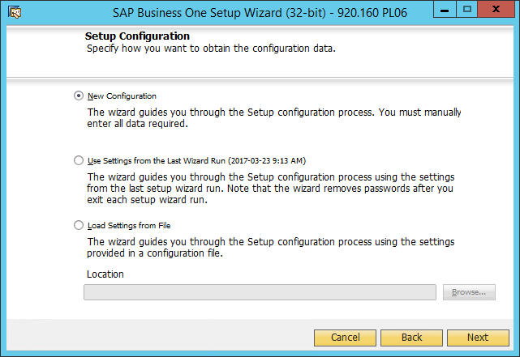

### Step 4: Config SLD

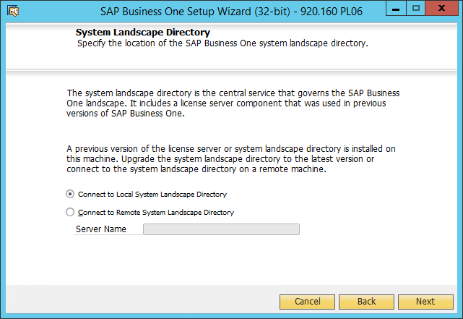

### Step 5: Config [B1SiteUser] Password

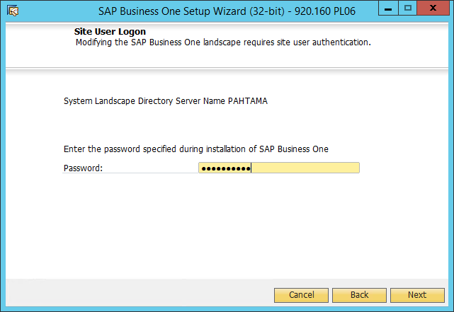

### Step 6: Config Database Connection

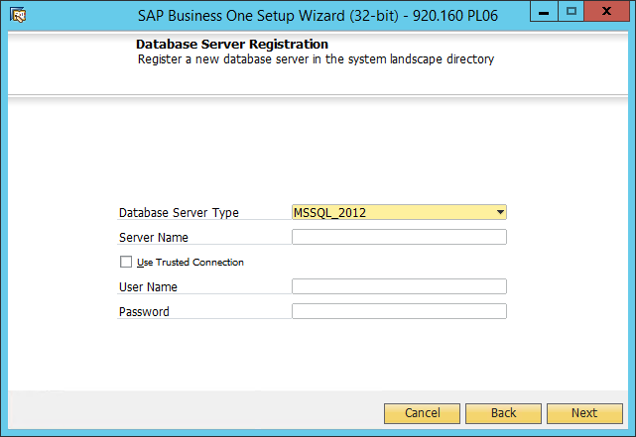

### Step 8: Input Database Information

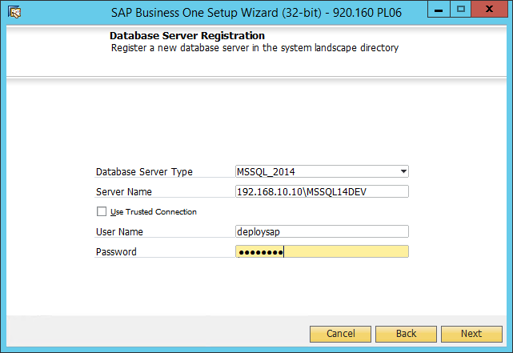

### Step 9: Finish Config Database

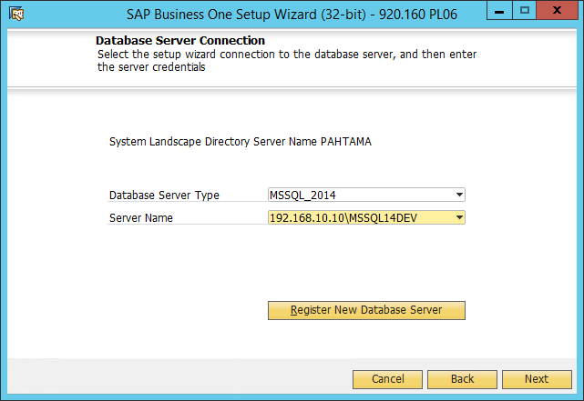

### Step 10: Select [Repository] Only

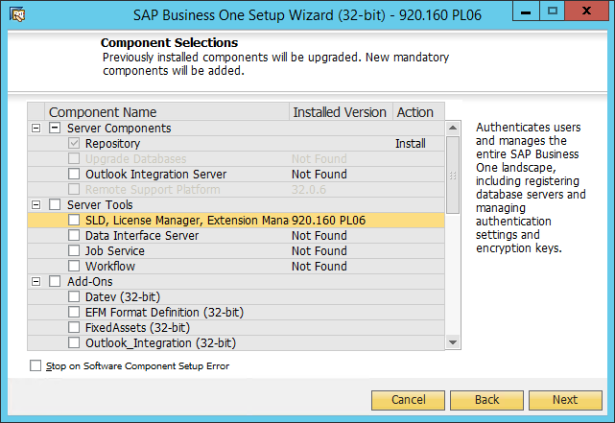

### Step 11: Review Settings

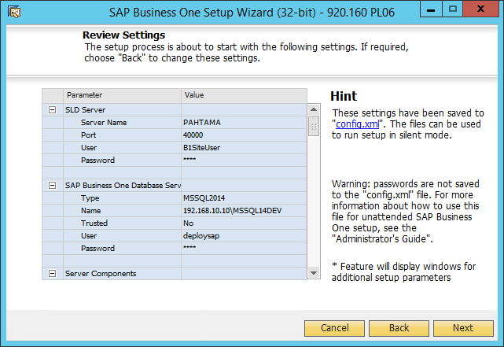

### Step 12: Begin Setup

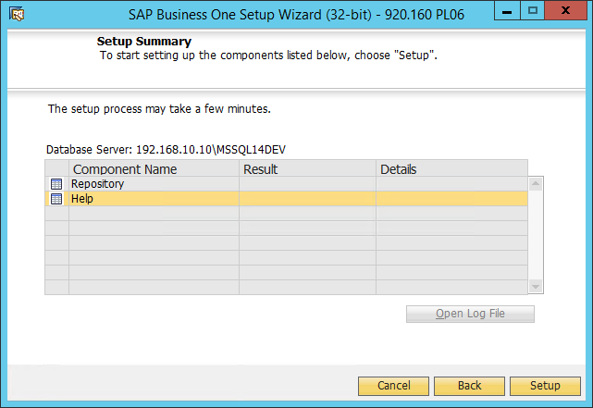

### Step 13: Processing… (Repository)

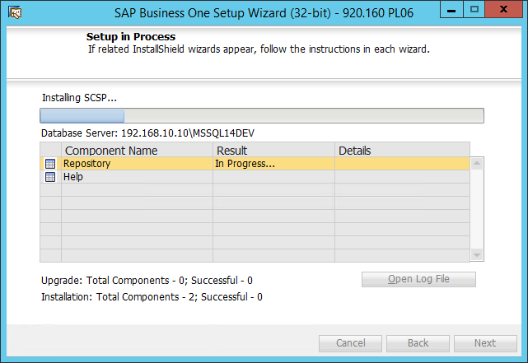

### Step 14: Processing…

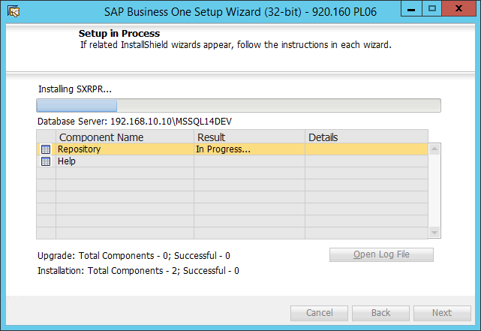

### Step 15: Processing…

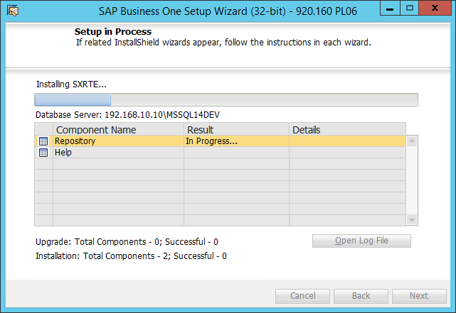

### Step 16: Processing…

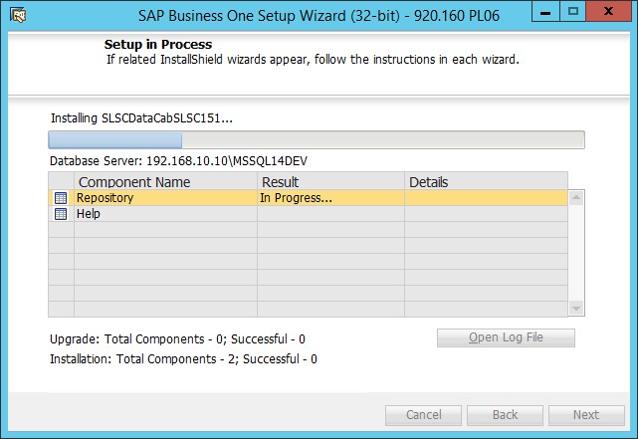

### Step 17: Processing…

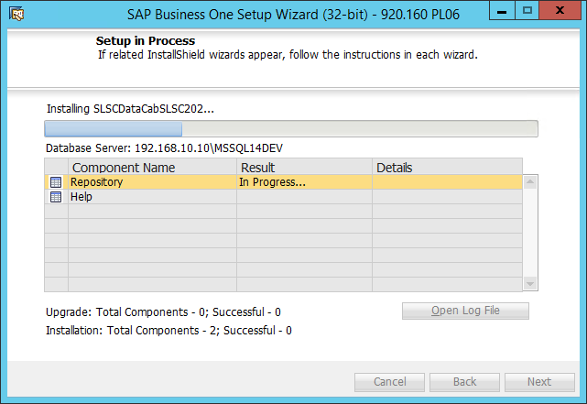

### Step 18: Processing…

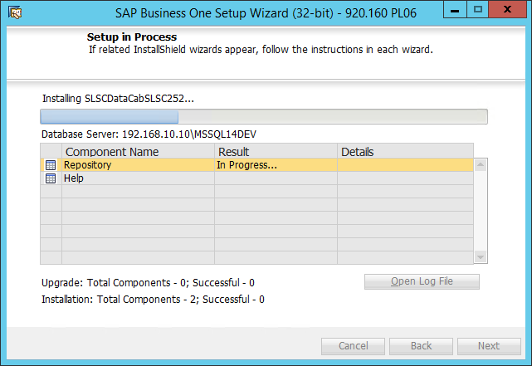

### Step 19: Processing… (Help)

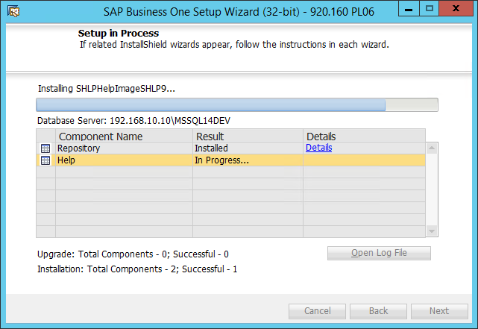

### Step 20: Setup Success

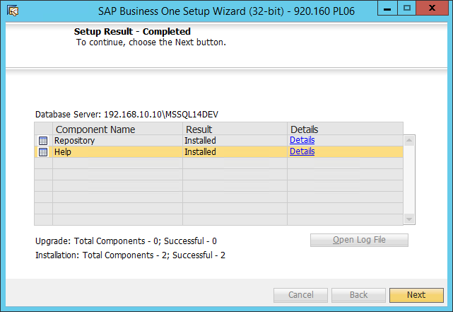

### Step 21: Sutup Success (Next)

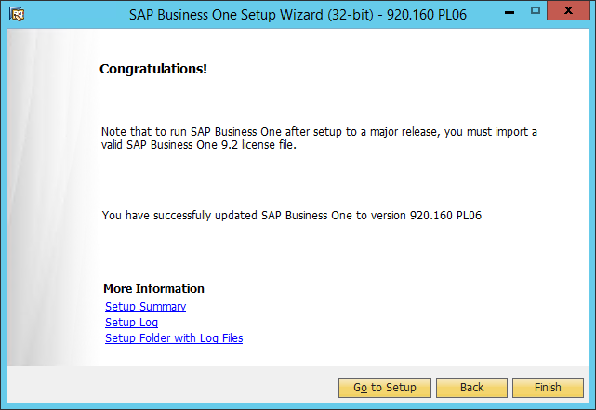

### - Finish -

## Setup SAP Server Tools

### Step 1: Begin

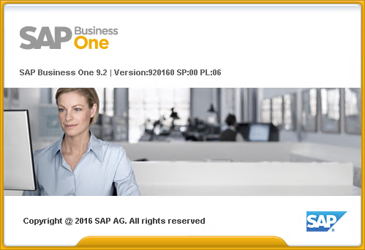

### Step 2: Setup Welcome

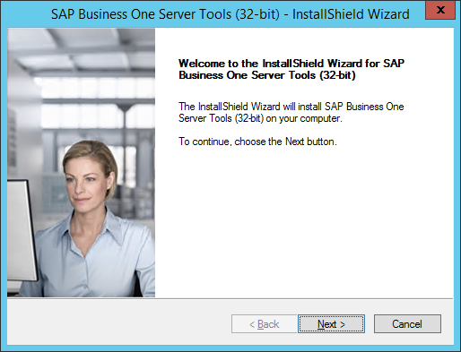

### Step 3: Setup Type

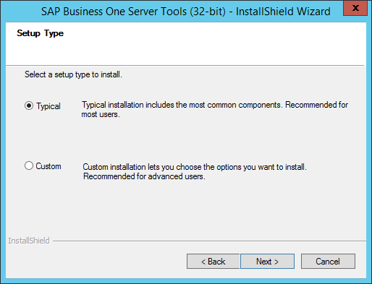

### Step 4: Landscape Selection

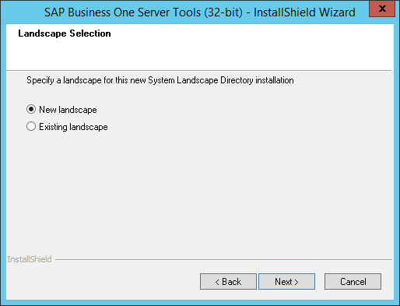

### Step 5: SLD

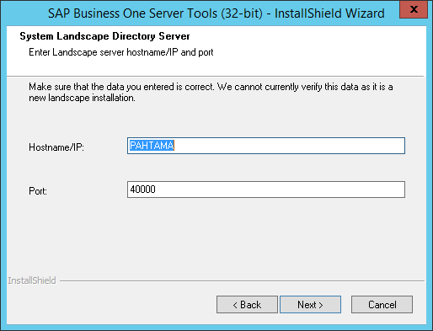

### Step 6: Config [B1SiteUser] Password

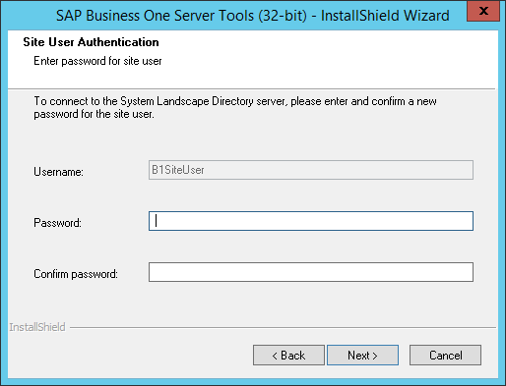

### Step 7: Input [B1SiteUser] Password

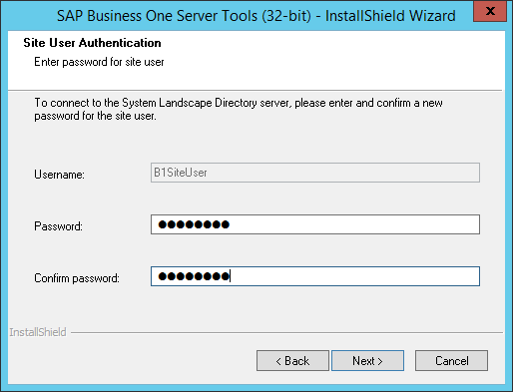

### Step 8: Select Node Type

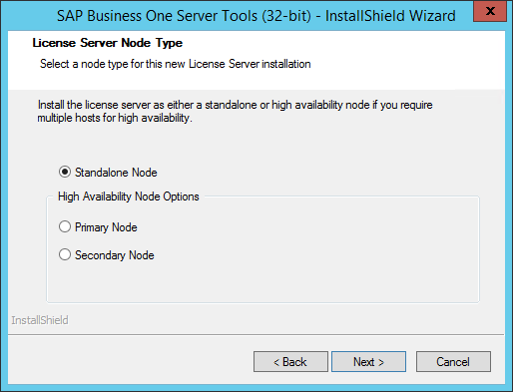

### Step 9: Select [Use Self-Signed Certificate]

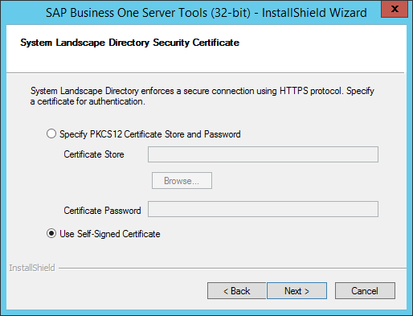

### Step 10: Config SLD Database

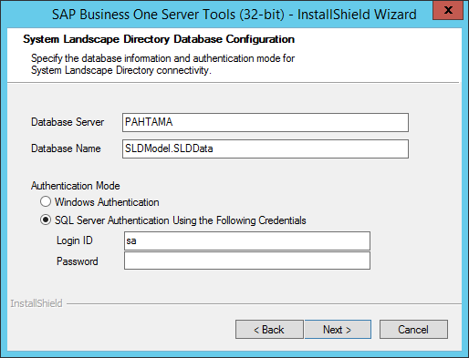

### Step 11: Config SLD Database

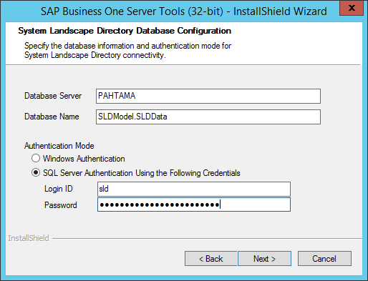

### Step 12: Begin Setup

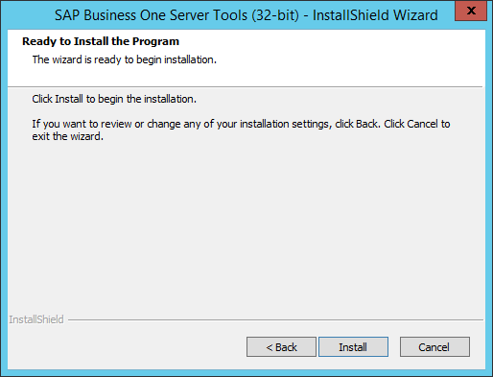

### Step 13: Setup Complete

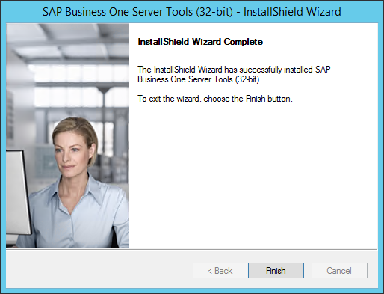

### - Finish -

# Setup S.Service

## Setup Website

### Step 1: Open IIS Management

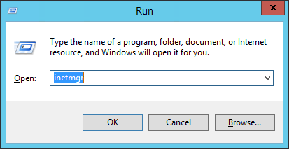

### Step 2: Create Application Pool

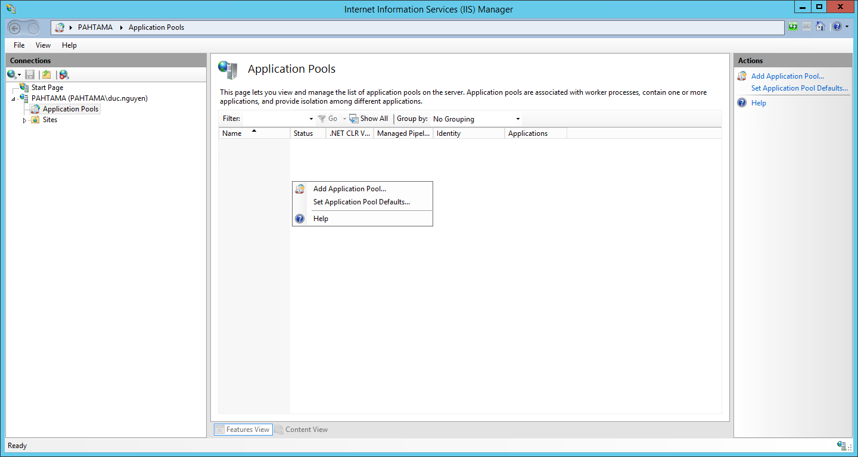

### Step 3: Set AppPool Name

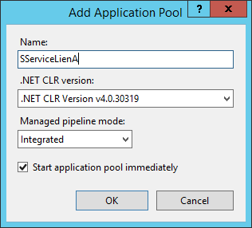

### Step 4: Config AppPool

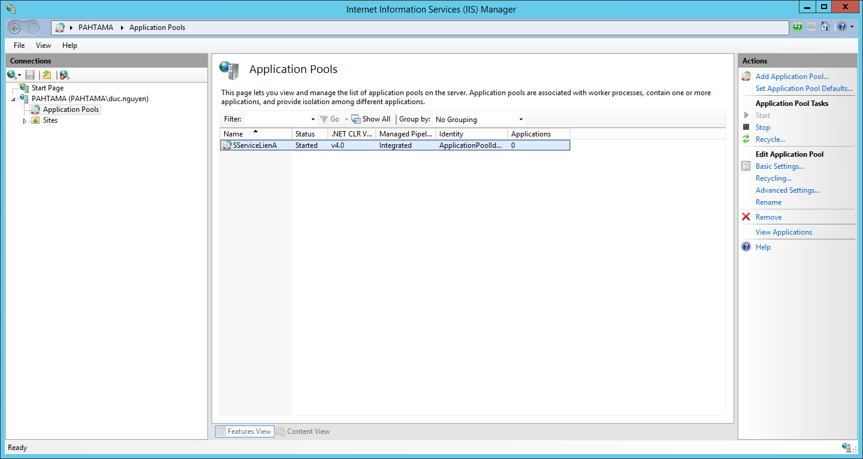

### Step 5: Open Advanced Settings

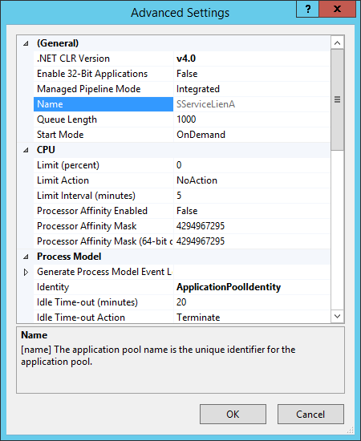

### Step 6: Select Identity

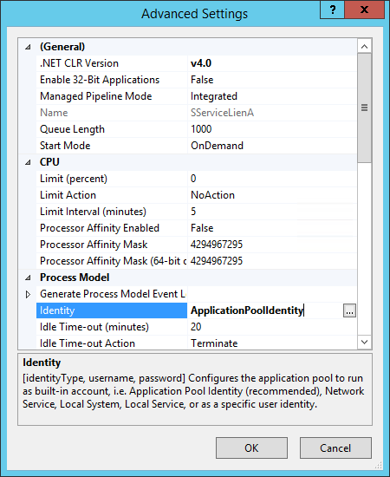

### Step 7: Change Identity

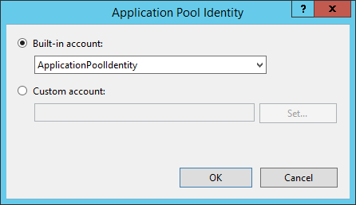

### Step 8: LocalSystem Identity

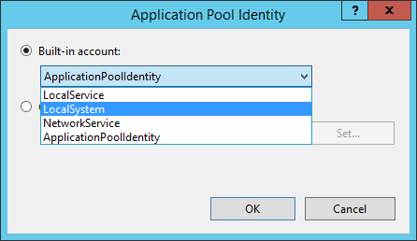

### Step 9: Finish Change Identity

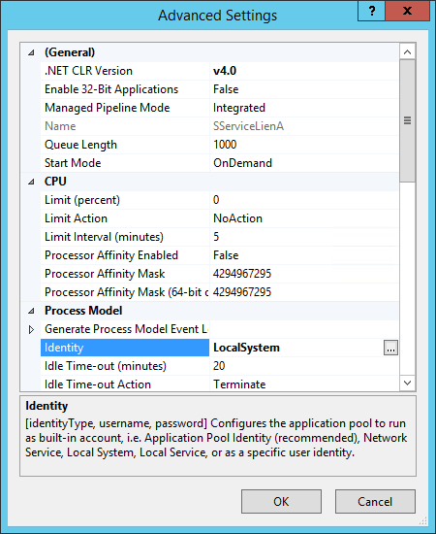

### Step 10: Create new Website

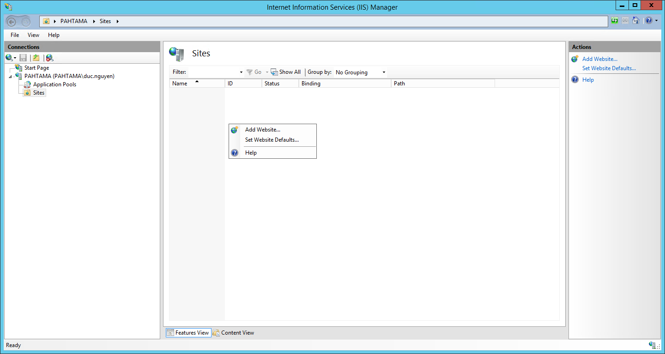

### Step 11: Config Information

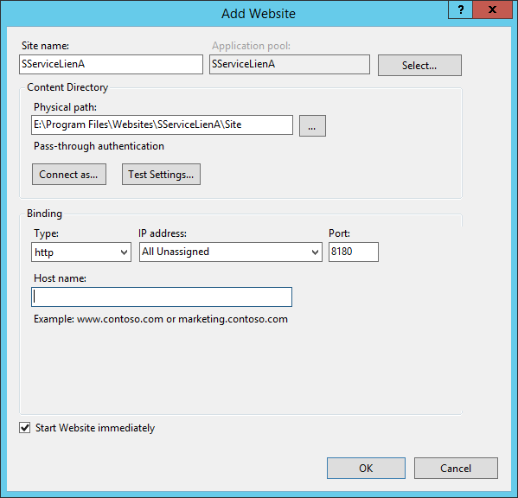

### Step 12: Uncheck [Start Website immediately]

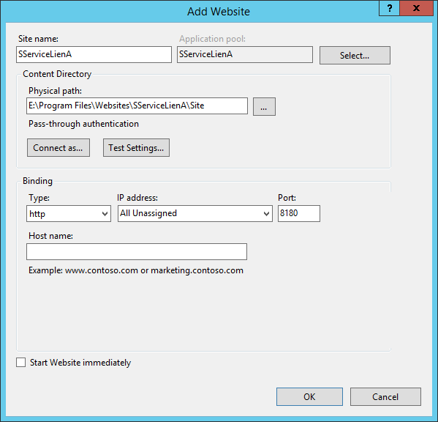

### - Press OK to Finish -

## Setup Window Service

# Setup Addon

## Login Extensions Site

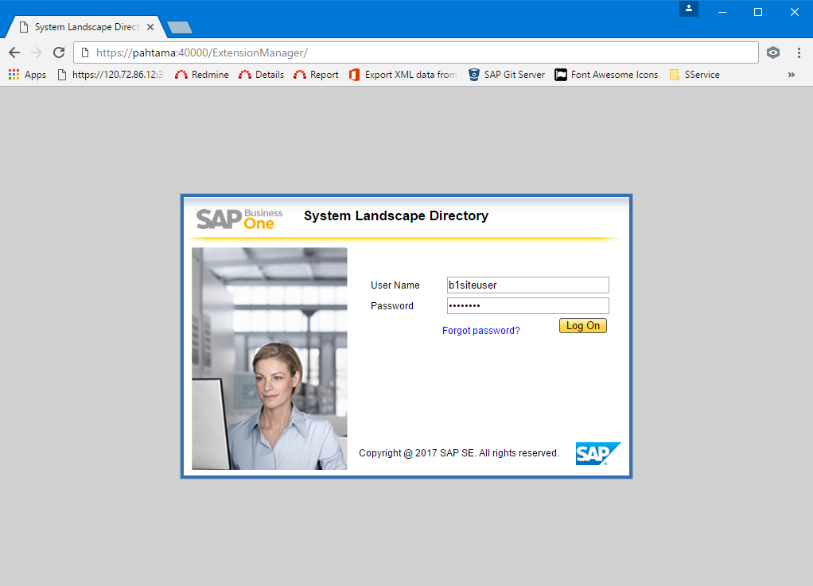

## Upload DMSpro Addon

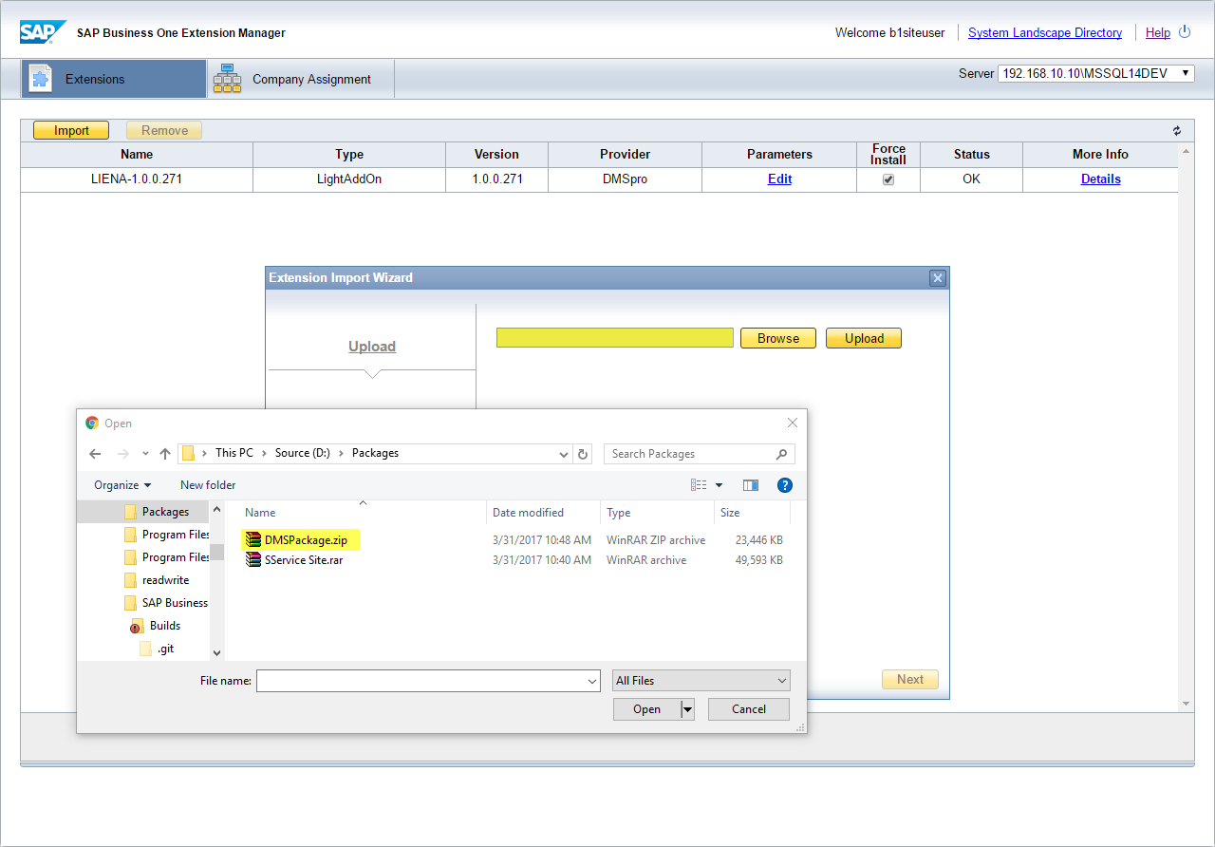

## Upload Success

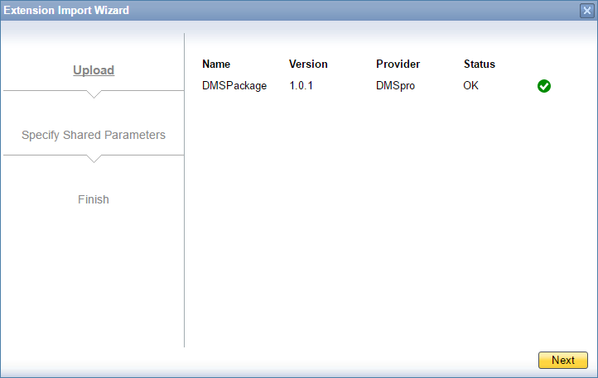

## Check Force Install

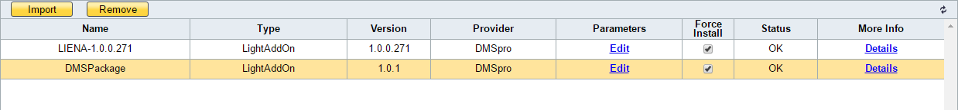

## Assign to Company

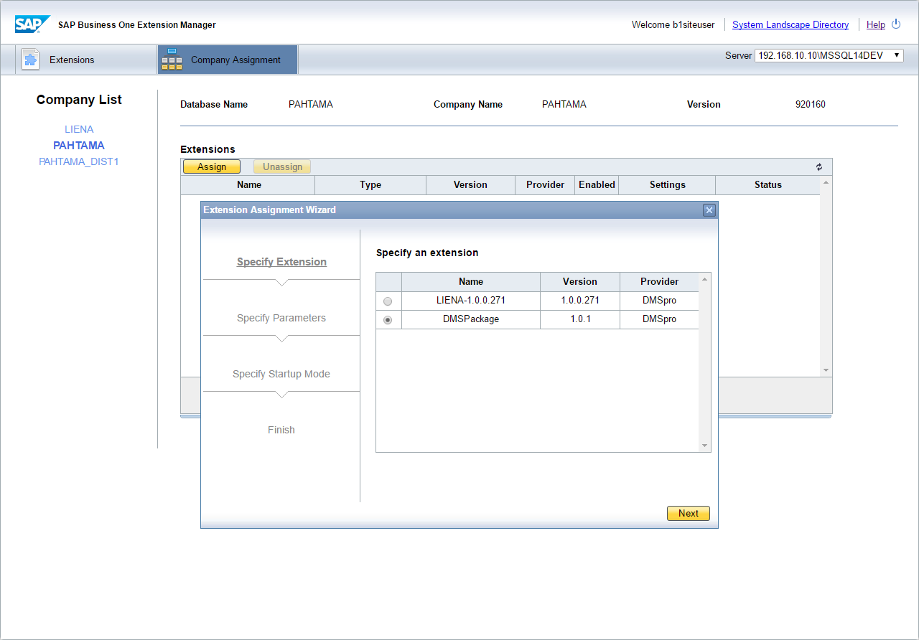

## Set Start Up Mode

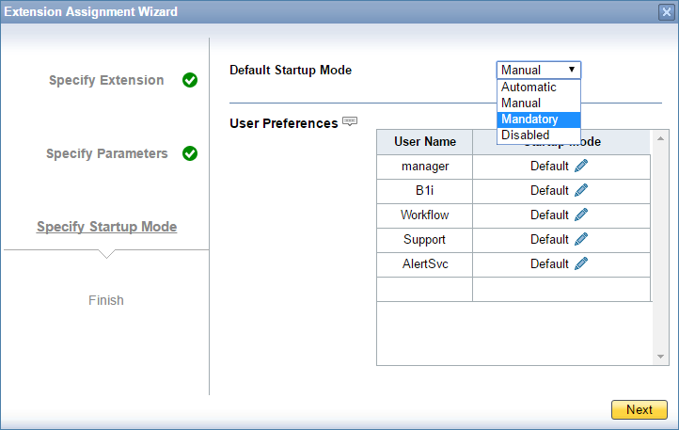

## Finish

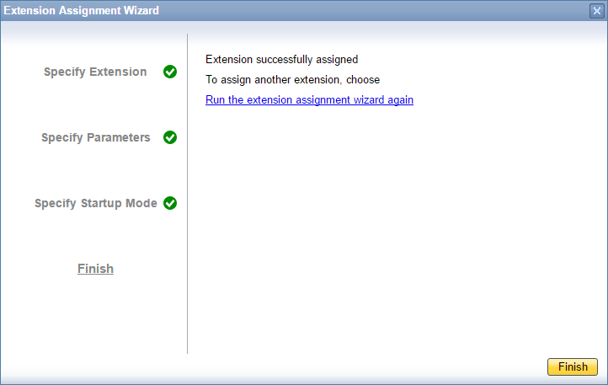

# Appendix A

## Glossary of Terms

Table 31: Glossary of Terms

|  |  |
| --- | --- |
| Term | Meaning |
|  |  |
|  |  |
|  |  |